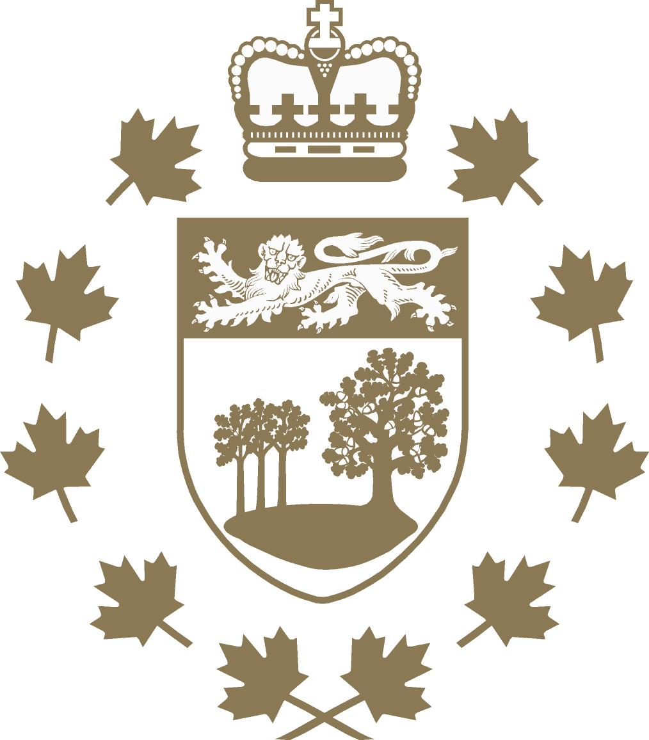

New Year’s Day Levee 2024

Charlottetown, December 18, 2023 -- Her Honour the Honourable Antoinette Perry, Lieutenant Governor of Prince Edward Island, welcomes Islanders and visitors to start off the 2024 year by visiting Government House for her annual New Year’s Day Levee.
Lieutenant Governor Perry hopes that everyone, young and old, will have the opportunity to drop by and ring in the new year by exchanging greetings and enjoying refreshments while listening to the seasonal sounds of the Singing Strings.
The Levee at Government House, the residence of the Lieutenant Governor, will take place on Monday, January 1, 2024 from 10:00 to 11:30 a.m.
Government House reminds visitors that parking on the grounds is very limited and restricted during the levee to those with mobility issues.

